1. Database configuration
   1. Register new device of type "Slip printer".

Add new record to the table [VG48***].[ DEVICE].  You can use the following query:

INSERT INTO  [VG48***].[DEVICE] ([DEVICE_HOST_NAME], [DEVICE_HOST_ADDR], [DEVICE_DESC], [DEVICE_TYPE_ID], [DEVICE_ACTIVE], [DEVICE_STATUS_ID],  [DEVICE_SERVICE_ID])

                    VALUES (<DEVICE_HOST_NAME>, <DEVICE_HOST_ADDR>,  <DEVICE_DESC>, 9, 1, 1, <DEVICE_SERVICE_ID>)

                     where

                         <DEVICE_HOST_NAME>  - the name of the machine on which print service is running;

                         <DEVICE_HOST_ADDR>  - ip of the machine on which print service is running. If print service was started on local machine - please set 'localhost';

                         <DEVICE_DESC>              -  printer name (e.g. 'EPSON TM-H6000IV');

                         <DEVICE_SERVICE_ID>    - id of device service (e.g '1'). **Please note**that specifying correct device service id is crucial for printing on expected printer;

       1.2. Assign registered *printer*(device with type of "Slip Printer") to needed workstation

               1.2.1. Go to database of appropriate environment;

               1.2.2. Add new record to the table [VG48***].[WORK_STATION_DEVICE]

                 You can use the following query:

INSERT INTO [VG48***].[WORK_STATION_DEVICE] ( [DEVICE_ID], [WORK_STATION_ID], [WSD_ENABLED], [IS_DEFAULT])

                        VALUES (<DEVICE_ID>, <WORK_STATION_ID>, 1, 1)

                 where,

                      <DEVICE_ID> - DEVICE ID of the previously registered printer;

                      <WORK_STATION_ID>  - is your workstation's ID;

1. Configure POS printer on a machine where device service is running.

2.1. Installing Microsoft Point of Service for .NET v1.14 (POS for .NET)

- Download **POSforDotNet-1.14.msi** by link <https://www.microsoft.com/en-us/download/details.aspx?id=42081>

- Install Microsoft Point of Service for .NET (POS for .NET) v1.14 on your device by double-clicking on the **POSforDotNet-1.14.msi** installer and following the installer wizard.

2.2. Installing Epson OPOS ADK

- [click here to download Epson's OPOS software](https://www.partycentersoftware.com/hubfs/ADK270ER15.exe). It comes in the form of a self-extracting exe that will put everything into C:\ by default. For simplicity's sake, you may want to tell it to extract somewhere such as your Desktop or Downloads folders.

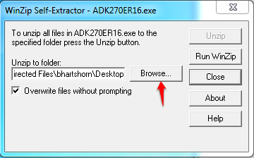

* Next, choose option to install using **no registry file**, and install as a **User**.

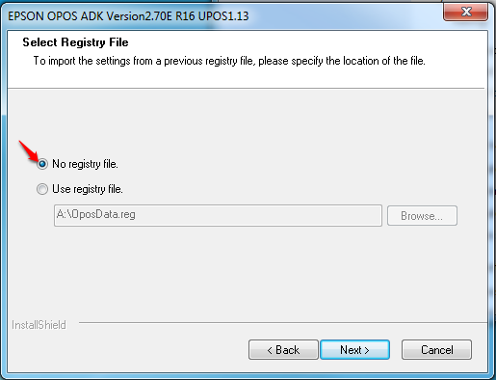

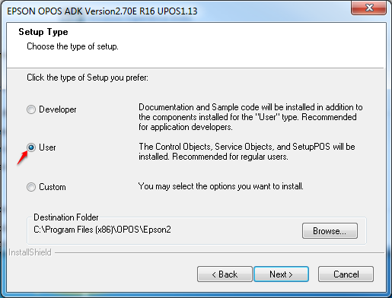

* Click "Next"
* There are 5 options for supported interfaces. Please check all options.
* Continue through the prompts until Epson OPOS finishes installing.

2.3. Configure POS printer

2.3.1. Run **EPSON OPOS ADK SetupPOS** as an administrator.

2.3.2. Right click on **POSPrinter (left upper corner)** and select ***Add New Device*.**

muedSOd 
dpH 
socn soco 

2.3.3. On the following screen under ***Select Device Name***, select the appropriate driver for your printer model.

EPSON opos ADK Version2.80E LIPOS 1.14 
File Edit 
Add New Device [Select DeviceNameKey] 
[4 " Device 
Coin 
POSPrinter 
Add New Device 
Select Device Nama 
TM-HSOOOIV 
Device Description 
Display Var2XK 
Select detailed model 
TM-HSOOOIV 
TMPORT 
EPSON TM-HSOOOIV pos Printer 
INF Fila Name 
C INF 
Add New L DN 
Set up a Bgical device name f necessary 
A logical device name indispensabla 
A logical device name set up in the case as the blank 
And. a logical device name can be set up even later 

2.3.4. Type "**Logical device name**". The name should be the same as configured device name in [DEVICE_DESC] column of [VG48***].[DEVICE] table

EPSON opos ADK Version2.80E LIPOS 1.14 
File Edit 
[4 " Device 
POSPrinter 
Add New Device [Select DeviceNameKey] 
Add Naw Device 
Select Device Name 
TM-HSC,CCIV 
Device Description 
Display Ver2 
Select detailed model 
used Port 
TMPORT 
EPSON TM-H60001V pos Printer 
INF Fila Name 
C INF 
Add New L DN 
Set up a Bgical device nama f necessary 
A logical device name indispensabla 
A logical device name isnt sat up in the case as the blank 
And. a logical device name can be set up even later 
EPSON TM-HSOOOIV 

—SELECT * FROM . CVG48121) . [DEVICE] 
WHERE DEVICE TYPE ID = 
Results Messages 
DEVICE ID DEVICE HOST NAME 
DEVICE HOST ADDR 
P avIoSIip 
DEVICE DESC 
EPSON TM-H60001V 
EVICE TYPE ID 
DEVICE ACTIVE 
CONFIG ID 
NULL 
DEVICE STATUS ID 
DEVICE SERVICE ID 

2.3.5 Click "Next"

* + 1. Configure connection

- If your printer connects by USB

Unlike other connection methods, Epson OPOS will probe for USB attached devices and create the port setting automatically. It should show as TMPORT[n](USB)[Device Name].

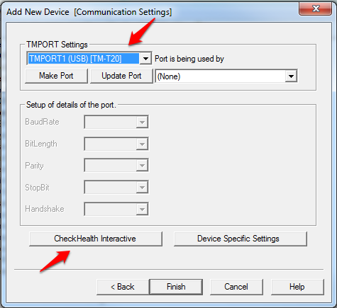

* If your printer connects by Ethernet

This section assumes your Epson printer is already on your local area network with a valid IP address. If your Epson printer still needs to be configured for your network, [see our help document about Epson NetConfig](https://success.agilesoftware.com/hc/en-us/articles/235972188-Configuring-and-Troubleshooting-an-Epson-Ethernet-Receipt-Printer).

First need to create a “port” for OPOS to access the printer through.

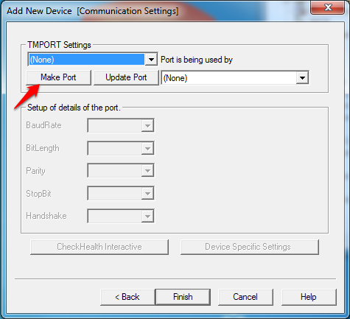

For Port Type, select NET. You'll now be able to enter the printer's IP address. If you have forgotten the IP address to your Epson printer, hold down the small reset button on the back of the unit (may require a pen to depress) just until it starts printing and release, at which point it will print a ticket with the IP address on it.

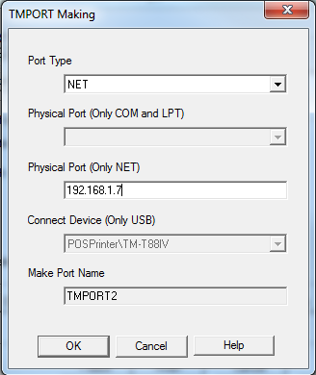

2.3.7. Before you hit Finish, please click on “***CheckHealth Interactive***” just to make sure that the communication settings are correct.

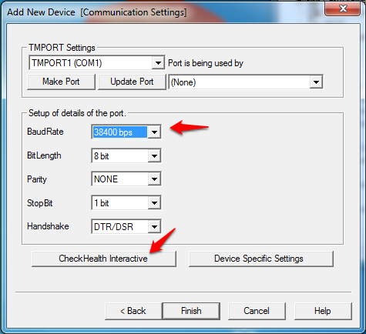

2.4. Modify the COM registry for all of the OPOS Common Control Objects (CCO) to use out of process COM servers.  Please find details by link <https://msdn.microsoft.com/en-us/library/dn638870(v=winembedded.4).aspx>

* Open **Windows PowerShell** as an administrator
* Run the next script from an administrator **Windows PowerShell** prompt:

# This Windows PowerShell script modifies the COM registry for all OPOS   
# Common Control Objects (CCO) so that they use out of process COM servers.  
# This enables OPOS service objects to work with both 32-bit and 64-bit   
# POS for .NET applications.

# .Synopsis  
# Create-Regkey: This function creates a new key in the registry  
function Create-Regkey {  
 param(  
 [string] $Key  
 )

if (!(test-path -path $Key -pathType container)) {  
 New-Item -path $Key -type container | Out-Null  
 }  
}

# .Synopsis  
# Set-RegEntry: This function creates a new registry key in the registry and  
# creates a new value in the key.  
function Set-RegEntry {  
 param(  
 [string] $Key,  
 [string] $Name,  
 [string] $PropertyType,  
 $Value  
 )

Create-RegKey -Key $Key  
 Remove-ItemProperty -Path $Key -Name $Name -ErrorAction SilentlyContinue  
 New-ItemProperty -Path $Key -Name $Name -PropertyType $PropertyType -Value $Value | Out-Null  
}

# Iterate through all of the OPOS Common Control Objects, setting registry   
# entries and values for each object.

for ($i = 2; $i -lt 38; $i++) {  
 $clsid = '{{CCB90{0:D2}2-B81E-11D2-AB74-0040054C3719}}' -f $i

Set-RegEntry -Key "hklm:\SOFTWARE\Classes\Wow6432Node\CLSID\$clsid" -Name 'AppID' -PropertyType String -Value $clsid  
 Set-RegEntry -Key "hklm:\SOFTWARE\Classes\Wow6432Node\AppID\$clsid" -Name 'DllSurrogate' -PropertyType String  
 Create-RegKey -Key "hklm:\SOFTWARE\Classes\AppID\$clsid"  
}